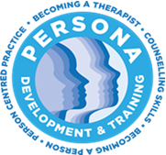
Persona
Certificate in Group Facilitation and Training Skills
Course Start Date: February 22nd 2026
Closing Date for Applications: January 26th 2026

APPLICATION FORM

Name

Address

Post Code
Mobile

Email

PROFESSIONAL QUALIFICATIONS
(e.g. PG Diploma in Counselling)
Title of Qualification | Training Institution/Awarding body | Dates

EDUCATIONAL QUALIFICATIONS
(e.g.BA in Sociology)
Title of Qualification | Training Institution/Awarding body | Dates

Please provide us with the following information:

- Professional Experience:
Please remember to attach a current CV with your application

- What is your motivation for applying for this course?

Please submit your completed application and associated attachments by email to:
admin@personacounselling.com
Closing date for applications is Monday January 26th 2026
Please note there will be a minimum number of participants for the programme to commence. The course will be limited to a maximum of 12 participants

